InternSpark Java Developer Internship
Task 3: Console-Based Student Management System
Objective
The objective of this task is to develop a simple console-based Student Management System using Java.
The application allows users to add, view, search, update, and delete student records through a menu-driven interface.
Features
- Add a new student
- View all students
- Search student by ID
- Update student information
- Delete student
- Validate numeric input
- Prevent duplicate student IDs
- Exit the application
Technologies Used
- Java
- ArrayList
- Scanner
- Object-Oriented Programming
- Console-based user interface
Project Structure
Task-3-Student-Management-System/
├── Student.java
└── StudentManagementSystem.java
Source Code
The project contains two classes:
Student.java
The Student class stores student information including ID, name, age, and course. It also contains getters, setters, and a method for displaying student information.
StudentManagementSystem.java
This class contains the main application and implements the menu-driven operations for adding, viewing, searching, updating, and deleting students.
How to Run
Compile both Java files:
javac Student.java StudentManagementSystem.java
Run the application:
java StudentManagementSystem
Sample Operations
1. Add Student
2. View Students
3. Search Student
4. Update Student
5. Delete Student
6. Exit
Sample Output
Enter your choice: 1

Enter Student ID: 101
Enter Name: Sachin
Enter Age: 21
Enter Course: B.Tech CSE

Student added successfully.
After selecting View Students:
----- Student List -----
ID: 101 | Name: Sachin | Age: 21 | Course: B.Tech CSE
Screenshot
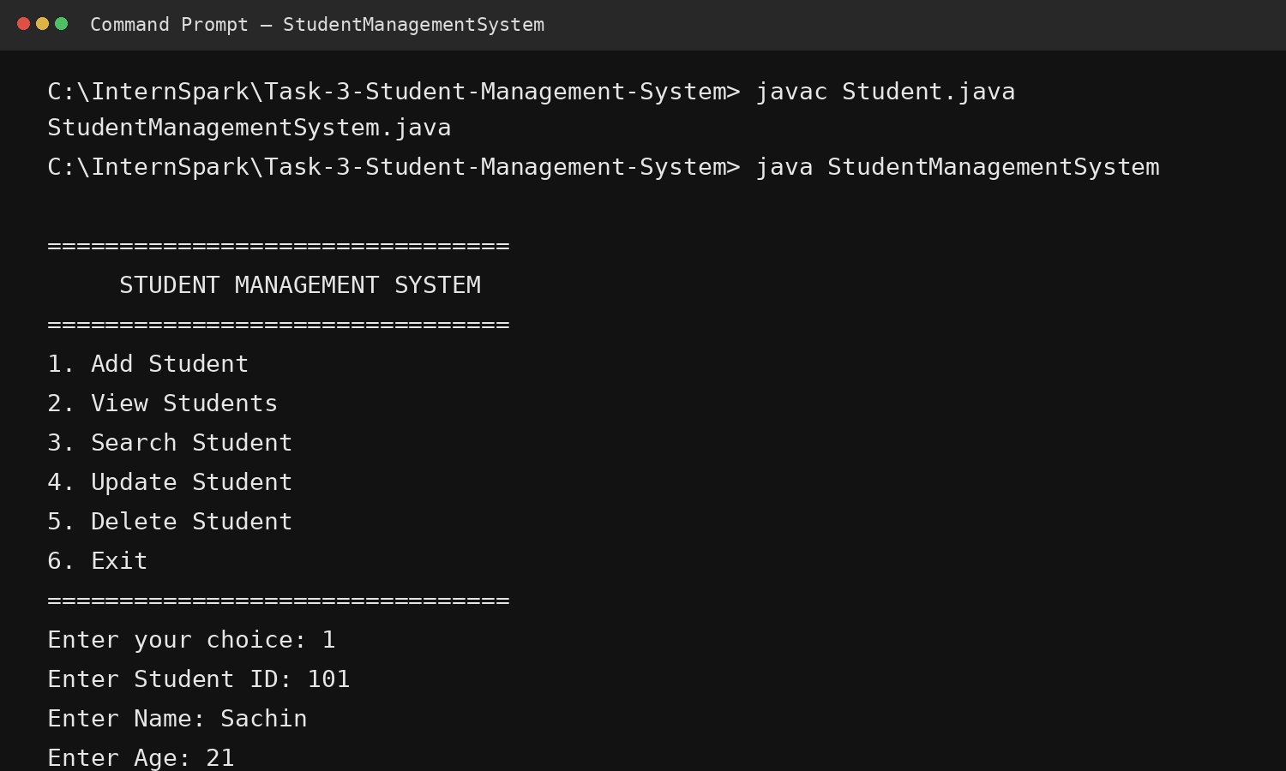GitHub Repository
[YOUR GITHUB LINK]
Conclusion
This project demonstrates practical use of Java collections, classes, objects, encapsulation, methods, loops, conditional statements, user input, and CRUD-style operations in a console application.

